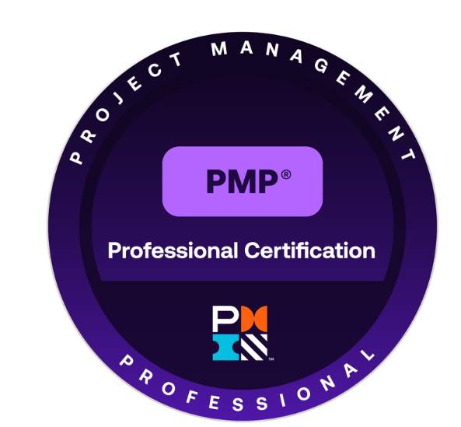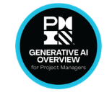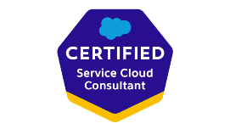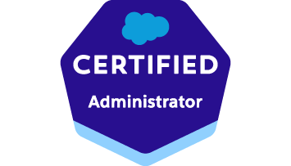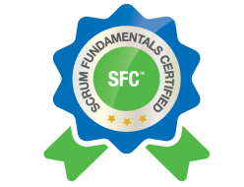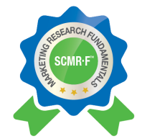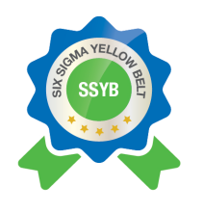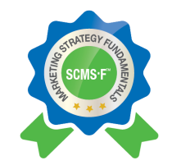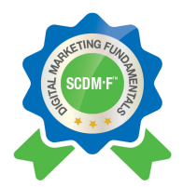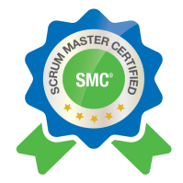

KUNAL DHINGRA
Project Management Professional (PMP) | Scrum Master Certified (SMC)
kunaldhingra1111@gmail.com | 331-231-9873 | linkedin.com/in/kunal-dhingra-60b949243

PROFESSIONAL SUMMARY
PMP-certified Project Manager with 15+ years of experience leading large-scale enterprise technology implementations across telecom, banking, retail, and public sector environments. Proven ability to deliver complex projects within defined timelines, scope, and quality standards while managing cross-functional teams and stakeholders. Strong expertise in full project lifecycle management, business requirements translation, PMO governance, and risk mitigation. Experienced working with state government agencies and regulated environments.
CORE COMPETENCIES
Agile Project Management • Waterfall / Hybrid Delivery • Scrum Master • Change Management • Risk & Issue Management • Resource Planning & Allocation • Portfolio Management • Stakeholder Engagement • Executive Reporting • Budget & P&L Management • Vendor & Contract Management • Digital Transformation • Cloud Migration (AWS) • Microservices / CNF Architecture • CI/CD Delivery • Process Optimization • OKR / KPI Tracking • Six Sigma (Yellow Belt) • Full Project Lifecycle (Initiation → Closure) • PMO Governance & Reporting • Government / Public Sector Projects • Vendor & Contract Management
CERTIFICATIONS
Project Management: PMP (Project Management Professional) | SMC (Scrum Master Certified) | SSYB (Six Sigma Yellow Belt) | Generative AI Overview for Project Managers
Technical: Salesforce Administrator | Salesforce Service Cloud Consultant
Marketing: SCDM-F (Digital Marketing Fundamentals) | SCMS-F (Marketing Strategy Fundamentals) | SCMR-F (Marketing Research Fundamentals)
PROFESSIONAL EXPERIENCE
Nokia (Contract) September 2022 — Present
Senior Technical Project Manager/Program Manager (IMS & Device Management)

- Delivered a $10M critical proof-of-concept for an IMS Voice Core program supporting 3M subscribers on Nokia Cloud Platform, achieving 100% on-time, on-budget delivery with zero major service disruptions.
- Led end-to-end change management and cutover planning for large-scale voice core modernization programs for Tier-1 telecom operators, ensuring smooth transitions with no customer impact.
- Managed a cross-functional global delivery team of 15+ engineers, data analysts, and business stakeholders across 3 time zones, maintaining alignment through structured governance and executive reporting cadences.
- Directed portfolio management across 4+ parallel project streams, aligning delivery roadmaps with strategic OKRs, budget constraints, and SOW commitments.
- Oversaw CNF capacity planning and deployments (CNCS, BGW, MRF), ensuring high availability, scalability, and regulatory compliance across cloud-native infrastructure.
- Delivered Autonomous Networks Data Suite (AN DS) use cases enabling subscriber experience analytics, anomaly detection, and incident management dashboards — reducing mean time to resolution by 30%.
- Established program governance frameworks, risk registers, and KPI dashboards to support executive-level decision-making and audit compliance.
- Managed vendor contracts and SLA performance, leading commercial negotiations with internal and external stakeholders to ensure adherence to delivery milestones.
- Drove continuous improvement initiatives using Six Sigma and Agile retrospectives, increasing delivery predictability by 20% across the program portfolio.
- Conducted resource planning and allocation across engineering and data teams, optimizing utilization and reducing delivery bottlenecks by 25%.

State of North Carolina (Contract) June 2020 – August 2022

Project Manager (Public Sector / Government)
- Led implementation of enterprise-level technology initiatives supporting state agency programs, ensuring alignment with government policies and compliance standards.
- Collaborated with business and agency stakeholders to define project scope, goals, and success metrics.
- Managed cross-functional teams across IT, business, and external vendors delivering projects within established timelines and budgets.
- Developed project plans, communication strategies, and reporting frameworks to manage risks, issues, and stakeholder expectations.
- Facilitated requirements gathering sessions and ensured traceability from business requirements through testing and implementation.
- Oversaw UAT coordination, defect tracking, and stakeholder sign-offs ensuring high-quality system delivery.
- Ensured adherence to PMO standards, documentation practices, and audit/compliance requirements.
- Acted as liaison between technical teams and business units to translate complex requirements into actionable solutions.
Loblaw Companies Ltd. (Contract) April 2018 —June 2020
Project Manager (Digital Platforms & Financial Services)

- Led end-to-end migration of President's Choice MasterCard accounts to the PC Optimum loyalty platform, managing change management, UAT coordination, and cutover for 2M+ customer accounts with zero service disruption.
- Coordinated cross-functional teams of 20+ across IT, Product, Operations, Marketing, Risk, and Customer Support — delivering the program on schedule and within a $4M budget.
- Defined project scope, roadmap, and WBS; tracked milestones and managed risks, issues, and dependencies across a multi-workstream delivery program.
- Gathered and documented business requirements; supported solution design for data migration, platform integration, and API connectivity between legacy and target systems.
- Managed UAT planning, defect resolution, and stakeholder sign-off, reducing post-launch critical defects by 40% compared to prior platform releases.
- Oversaw data migration activities including data mapping, validation, and reconciliation across 15+ data sources, ensuring 99.9% accuracy at cutover.
- Delivered regular executive reporting and steering committee updates, ensuring full visibility into program status, risks, and budget spend.
- Ensured regulatory compliance with financial services and data privacy requirements throughout the delivery lifecycle.

Kotak Mahindra Bank Pvt Ltd January 2015 — April 2018
Project Manager (Digital Banking)

- Managed end-to-end delivery of digital banking platform enhancements and cloud migration initiatives on a hybrid AWS and on-premises architecture integrated with core banking systems.
- Led Agile/Scrum delivery across sprint planning, backlog refinement, and retrospectives for a team of 12 developers — improving velocity by 35% over 18 months.
- Coordinated cross-functional teams across IT, Product, UX, Operations, and DevOps for customer-facing web and mobile banking solutions serving 500K+ users.
- Managed resource planning, capacity forecasting, and vendor delivery performance, ensuring adherence to project budgets averaging $2M per initiative.
- Oversaw UAT and system integration testing for 10+ releases, managing defect resolution and securing stakeholder sign-off for production readiness.
- Drove change management and stakeholder communication for platform upgrades, achieving 95%+ user adoption within 60 days of go-live.
- Maintained risk registers and escalation frameworks, proactively resolving 90% of risks before they impacted delivery timelines.

HDFC Bank January 2010 — January 2015
Project Manager (CRM & Enterprise Platforms)

- Managed end-to-end delivery of ServiceNow ITSM and Salesforce CRM implementations, on time and within budget, supporting 5,000+ internal users across 200+ branches.
- Led digital transformation initiatives across ServiceNow and Salesforce ecosystems, reducing manual workflow processing time by 45% and improving SLA adherence to 98%.
- Coordinated cross-functional teams across business and IT, managing project scope, resource planning, milestones, and executive reporting for portfolios of up to $3M.
- Oversaw UAT, deployment activities, and post-implementation stabilization for CRM and workflow platforms, achieving zero critical post-launch defects on flagship releases.
- Established governance and reporting frameworks improving project visibility, audit compliance, and executive decision-making across the IT delivery organization.
- Managed change management processes for enterprise platform rollouts, training 500+ end users and achieving full adoption within 45 days of go-live.

SKILLS & TOOLS
Project Management: Agile, Scrum, Waterfall, Hybrid, Sprint Planning, Backlog Refinement, Risk Management, Change Management, Resource Planning, Portfolio Management, Stakeholder Engagement, Executive Reporting, OKRs, KPIs, Governance, SOW, SLA, UAT, CI/CD
Tools & Platforms: Jira, Microsoft Project (MPP), Microsoft Excel, SharePoint, Confluence, ServiceNow, Tableau, Power BI, Salesforce CRM, AWS
Technical: Cloud Migrations (AWS), Microservices / CNF Architecture, API Integration, Data Migration, Core Banking Systems, CRM Platforms, ITSM Platforms
EDUCATION
Master of Science in Computer Science: Maharshi Dayanand University (MDU), Rohtak, India
Bachelor of Commerce: University of Delhi, New Delhi, India

